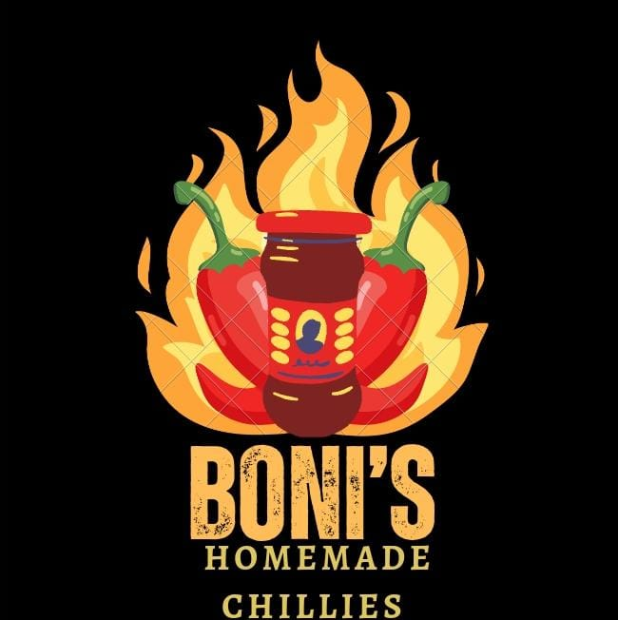

# Boni’s Homemade Chillies

Website Project Proposal

1. Organisation Overview

Boni’s Homemade Chillies is a proudly South African brand founded in 2022 by Boniswa Mabunda. The story began with a secret family recipe created by Boniswa’s mother, a passionate cook whose homemade chilli sauce quickly became a household favourite. Inspired by her mother’s legacy, Boniswa decided to share this unique recipe with the world.

Although Boniswa moved from her hometown of Johannesburg (Lenasia, Lehae Ext 1) to Pretoria (Sunnyside), she never lost sight of her dream. She faced challenges but remained committed to building something meaningful—not just a business, but a brand rooted in tradition, love, and perseverance. Her journey reflects resilience: turning a simple family recipe into a growing entrepreneurial venture.

Boni’s Homemade Chillies is more than just a product; it’s a story of family, culture, and ambition. Every jar represents heritage, passion, and the hope of creating opportunities for others.

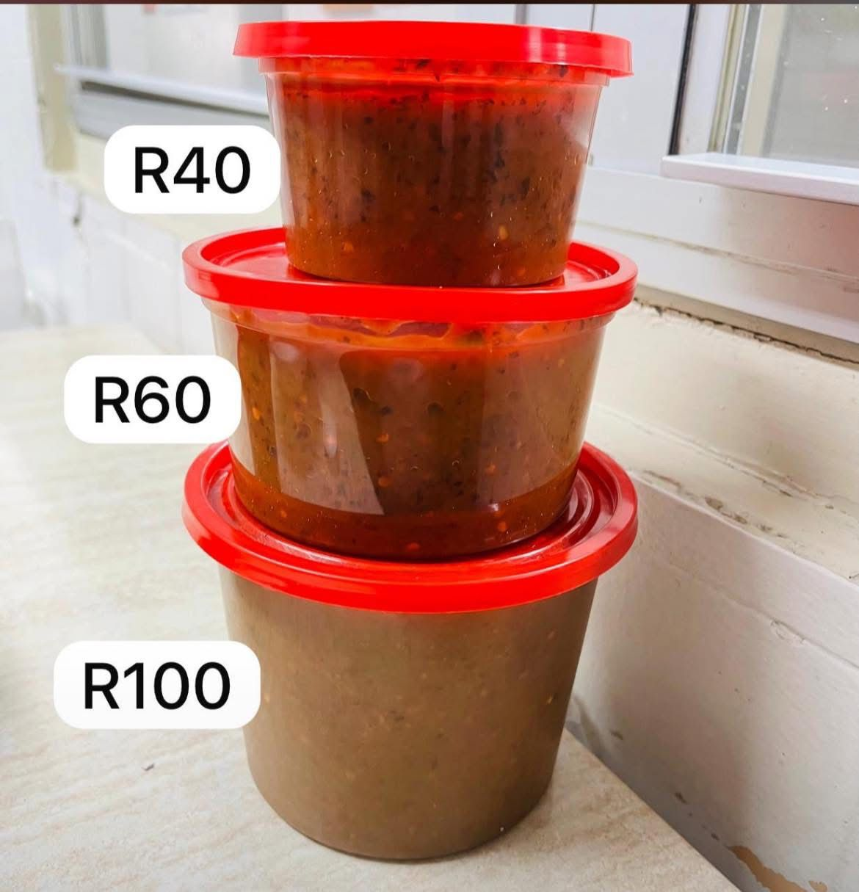

# Mission & Vision

Mission: Share authentic homemade chillies while creating jobs and uplifting communities.

Vision: Grow into a globally recognized brand that celebrates African tradition and flavour.

# Target Audience

Local customers in Johannesburg, Pretoria, and nationwide (with free delivery).

Online shoppers seeking authentic, homemade products.

Investors, sponsors, and retailers looking for unique African brands.

# Unique Selling Points

✅ Free delivery across South Africa.  
✅ Family legacy recipe passed down through generations.  
✅ Bold expansion plans with a vision for global growth.

# Website Purpose

Gain recognition from large companies, sponsors, and funders.

Sell products at reasonable prices directly to customers.

Recruit and train workers to support business growth.

Get in Touch  
📞 068 439 9717/073 550 0849  
📧 BoniswaMabunda@gmail.com